Practical Test
120 minutes

- Fetch data from following URL
- Bind data to UITableview
- Current visible cell's music should play, if user scroll to other cell then pervious music should stop and new sound should start play.
- Music should play in infinite loop

URL : ttps://api.screamxo.com/mobileservice/Posts/getdashboardmedia
Method : POST
Header :
userdevice: C238390-3668-4EA6-B244-FB5CB0DEE57C
usertoken : jLzkR98eAG

Param:
uid : 1
offset:1
limit:10
posttype:0
myid:1

Expected output:

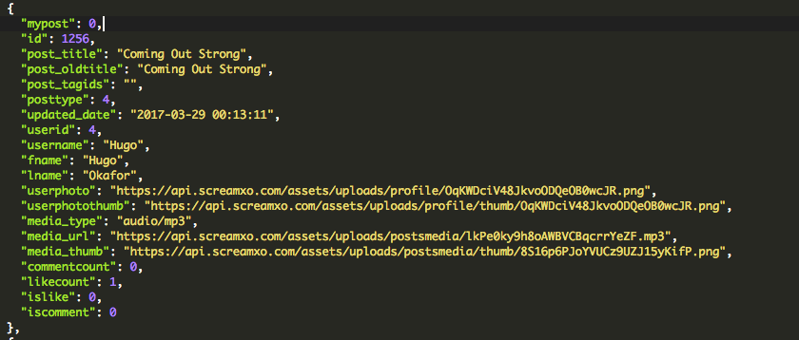

UI should looks like below:
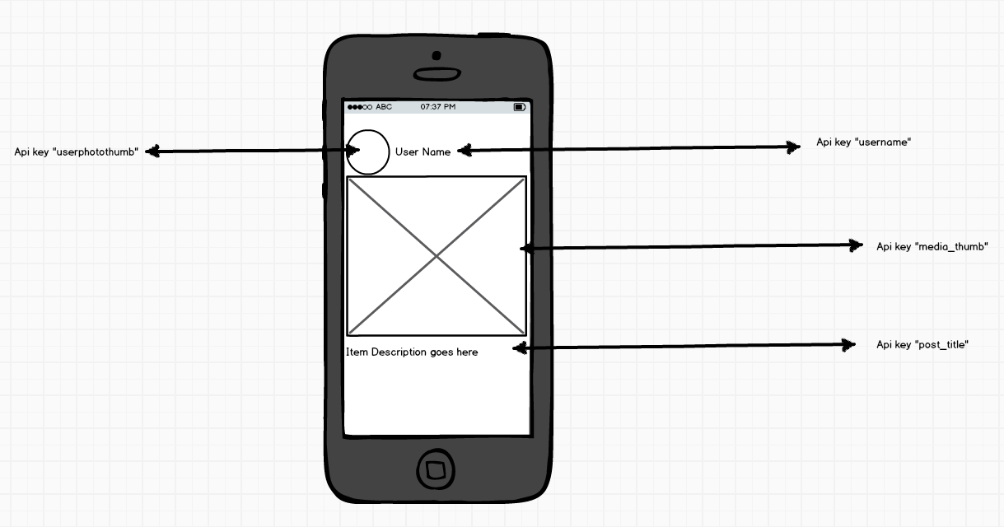

Bind Following details from api key to UI:

User image key “userphotothumb”
User Name key “username”
Media URL key “media_thumb”
Post Title key “post_title”

Conditions:

    - Check “media_type” key from api, iF it is “audio/mp3” then visible cell's music should play. If “media_type” is image/png then just show image.
    - Post title can be more than one line.
    - Media image will be square according to screen size

Note:
    - Develop demo in swift
    - Use MVC architecture
    - Optimise code
    - Use constraints

PS: check attached image in folder of screen shot in this paper is not visible

